**Big Data Management - Assignment 1**

**Music Recommendation System**

**Akshay Kumar (G24AI1033)**

Question 1 : Insert the above into the recommendations table

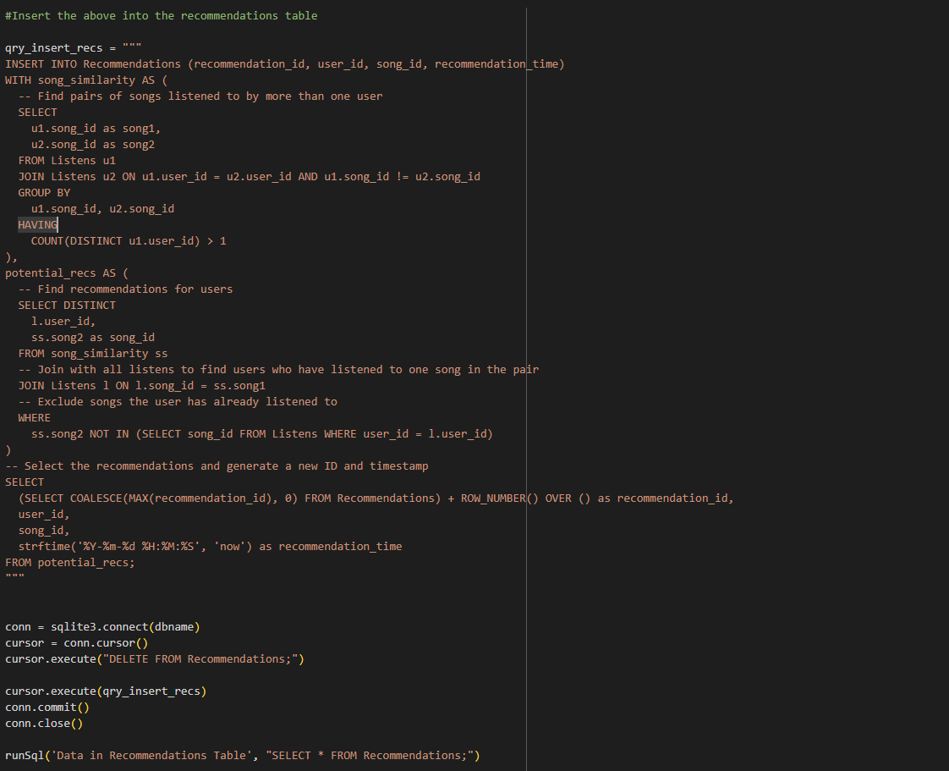



**Question 2 : Generate the recommendations for Minnie**

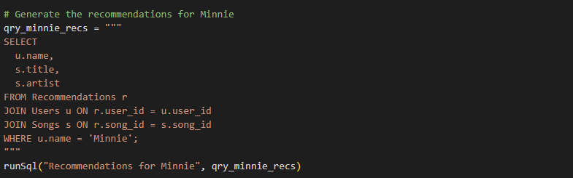



**Question 3 : Re-do the generation of recommendations now on the basis of listen time**

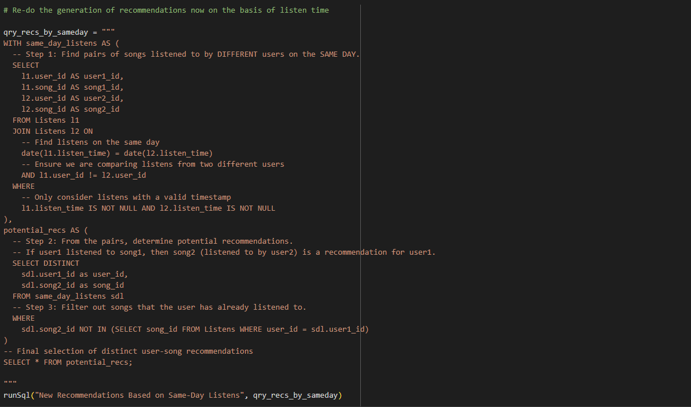

**Question 4 : Generate new recommendations**



**Question 5 : What are the differences with the static method on #2 above**

|  |  |
| --- | --- |
| **Shared Listening Recommendation**  **(Method 1)** | **Listening Time-based Recommendation**  **(Method 2)** |
| This method looks at all songs a person has ever listened to. | This method only looks at songs where we know the exact listen time. |
| It uses all the data in the Listens table, even if the listen_time is empty. | It throws away any listen that doesn't have a timestamp, using less data. |
| Its goal is to find users who share the same overall taste in music. | Its goal is to find users with shared taste, but only using "verified" (timestamped) listens. |
| Because it used all the data, it found that Mickey and Daffy both liked similar songs. | Because it threw away data, it couldn't find any two users who liked similar songs. |
| This method worked and gave us two good recommendations for Minnie. | This method failed and gave us zero recommendations. |
| It’s a more robust approach when your data might be incomplete. | It's not a good approach for our dataset because too much data was missing. |
| It assumes that any listen, with or without a time, tells us something useful. | It assumes that only a listen with a timestamp is trustworthy enough to be used. |
| The recommendations are based on a user's entire listening history. | The recommendations are based on a small, filtered part of a user's history. |
| This method successfully found a pattern in the data. | This method failed because filtering the data removed the very pattern it needed to find. |
| Gave useful recommendations by looking at the bigger picture. | Gave no recommendations because it was too strict with the data it used. |